**CICD Pipeline using AWS Code Pipeline:-**

We are going to use components:

GitHub: Source code Management & for web hook part   
code build : to build Docker images   
ECS fargate cluster : For deploying applications to environments  
  
ECS fargate is AWS web services for orchestrating production grade Docker work loads .

1. Creating of ECS Cluster:  
      
   create with default VPC – name of cluster myhome.  
     
   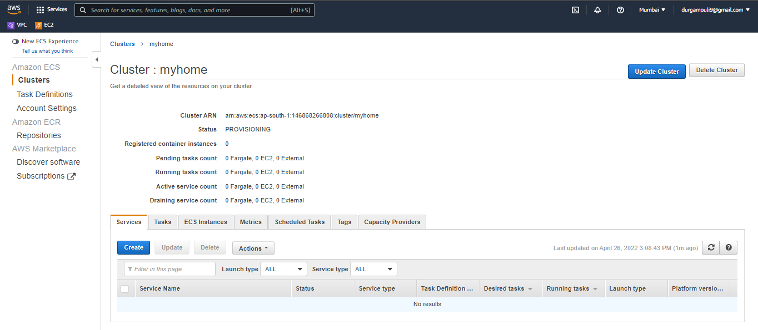
2. Create an Repository:

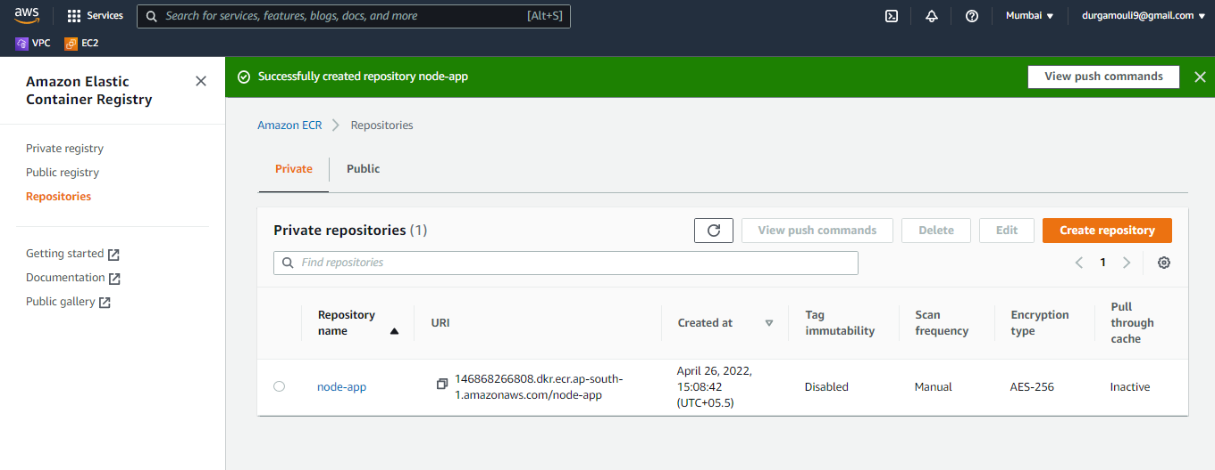

3) Create Task definition:

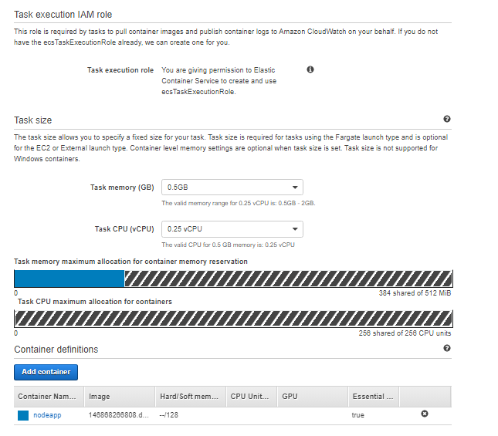

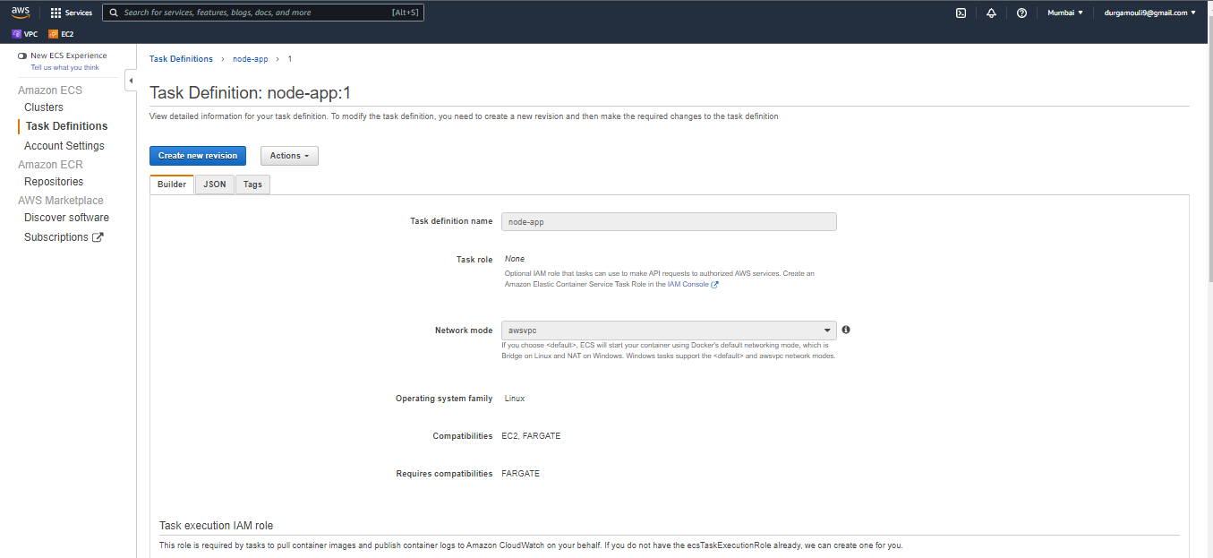

**Using service we will be going to create multiple tasks nothing but replicas**  
  
  
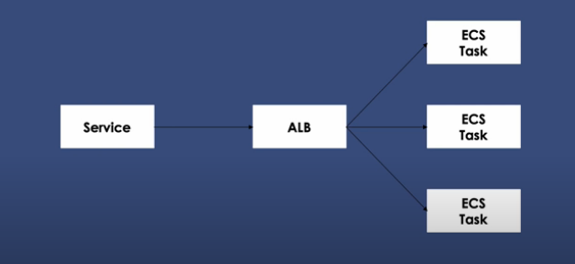

Customer’s hits to application load balancer and alb distributes the traffic across multiple replicas  
  
  
4) Create Target Groups:

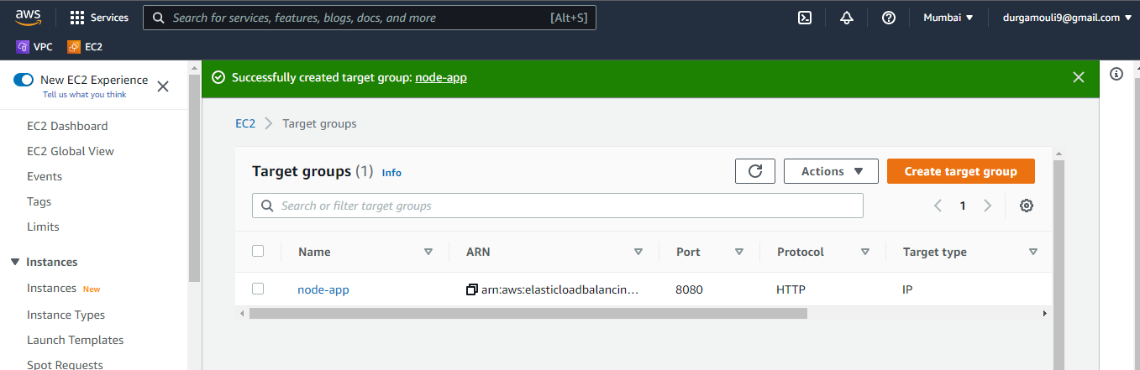

5) Create an auto scaling load balancer:   
  
  
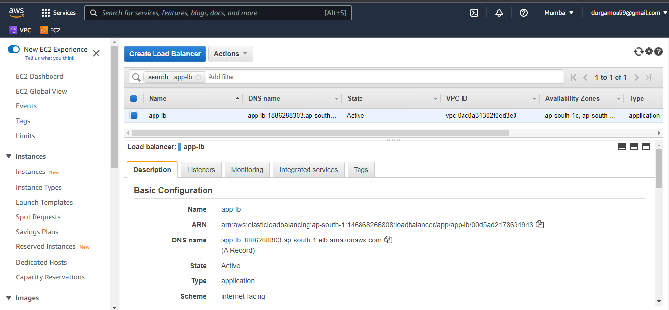

6) Create a service:   
  
service uses task definition to create containers

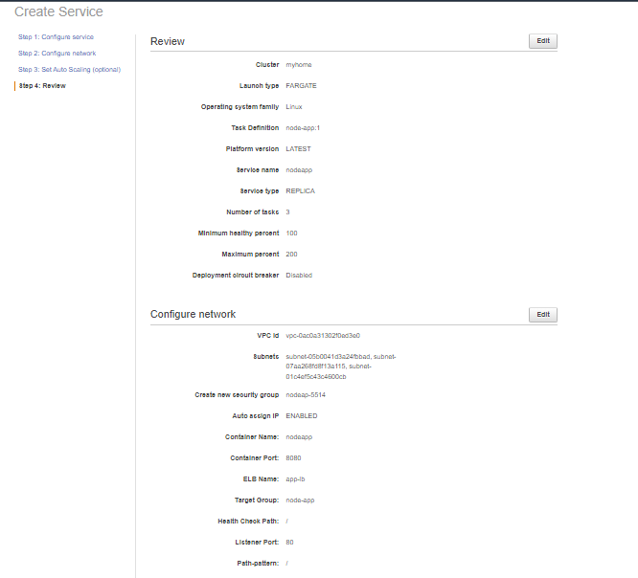

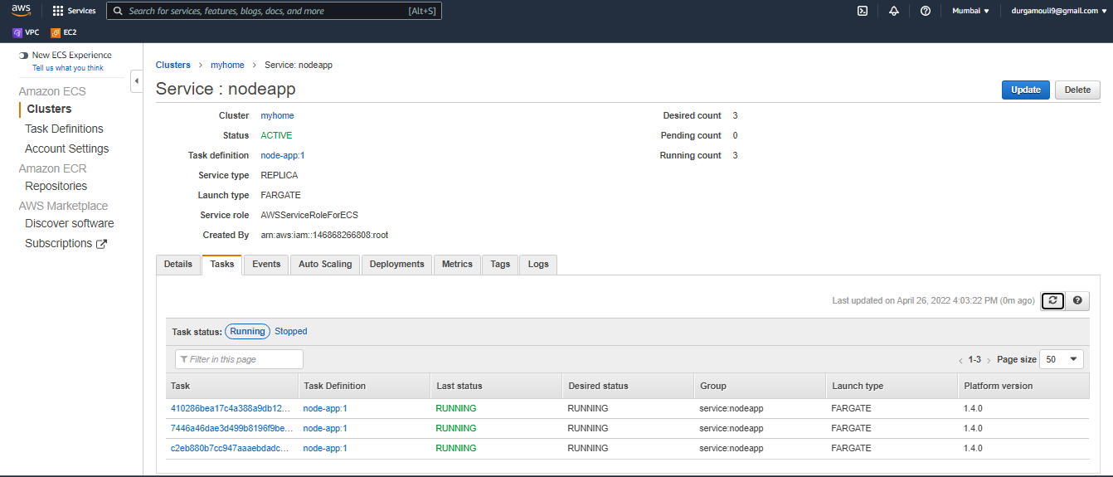

7) Push sample code and create image from EC2 Instance:   
  
Push commands:  
  
* Login



* Building an Docker image  
    
  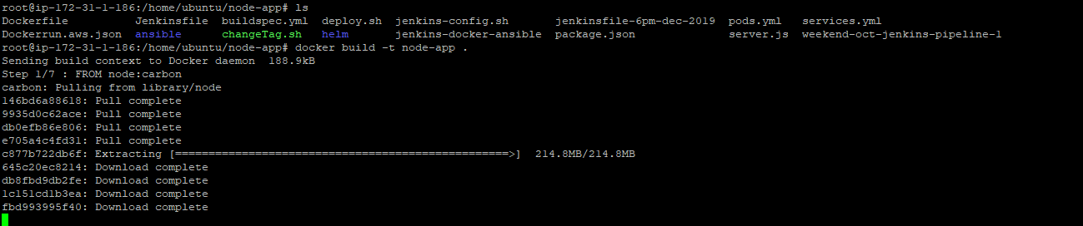

*Tag & push and image to ECR  
  
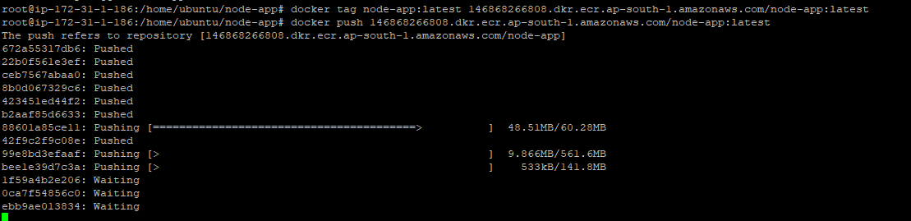

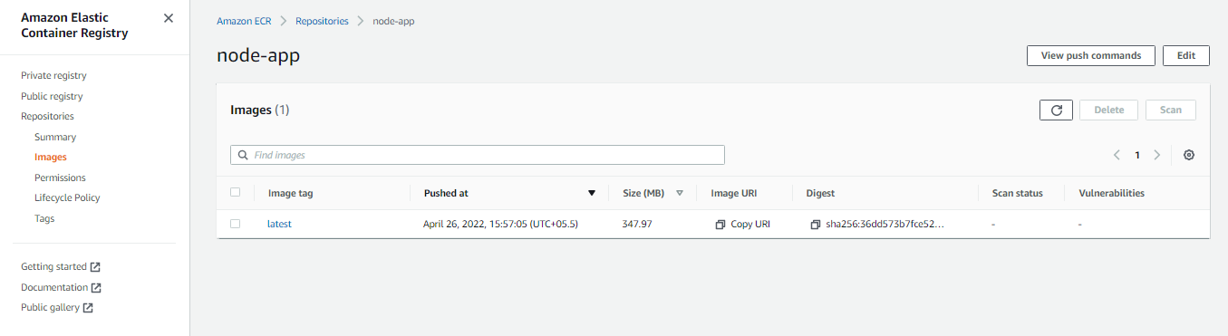

**To cross-check up to now either we have done correct or not **  
  
  
In your targets groups we need to see 3 targets:  
  
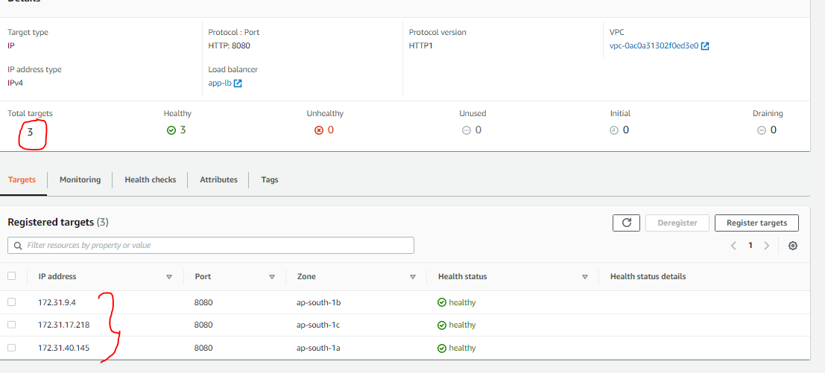  
  
  
**Pick up DNS name from ELB & paste it into browser: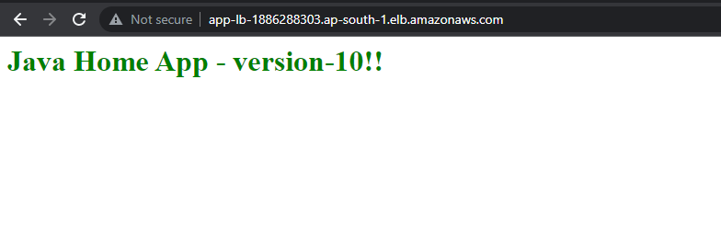

8)Setting up CICD pipeline:  
  
* Code Build:  
  
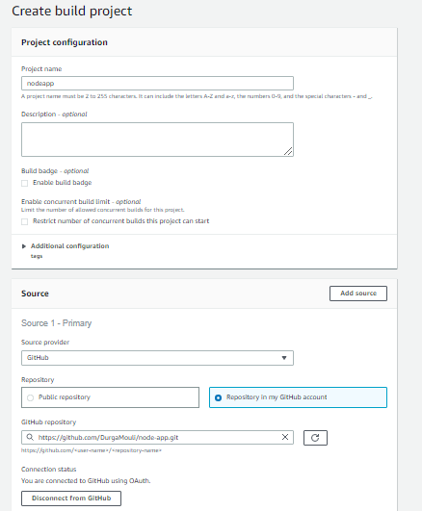

If you need to push automatically once any commit happens in SCM, you need to enable webhook,  
  
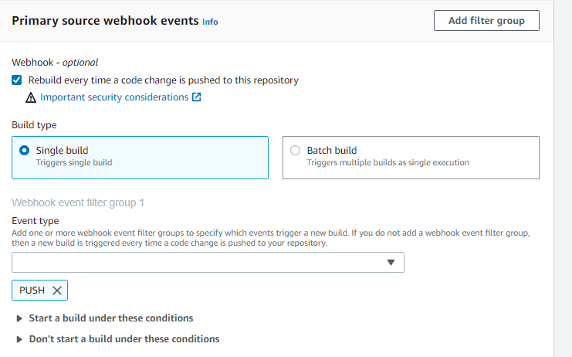

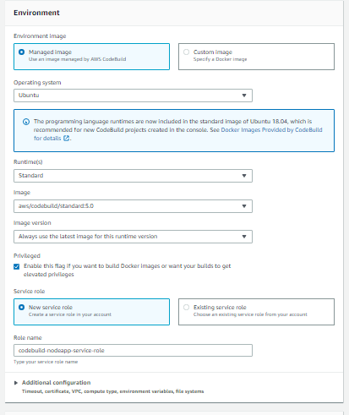

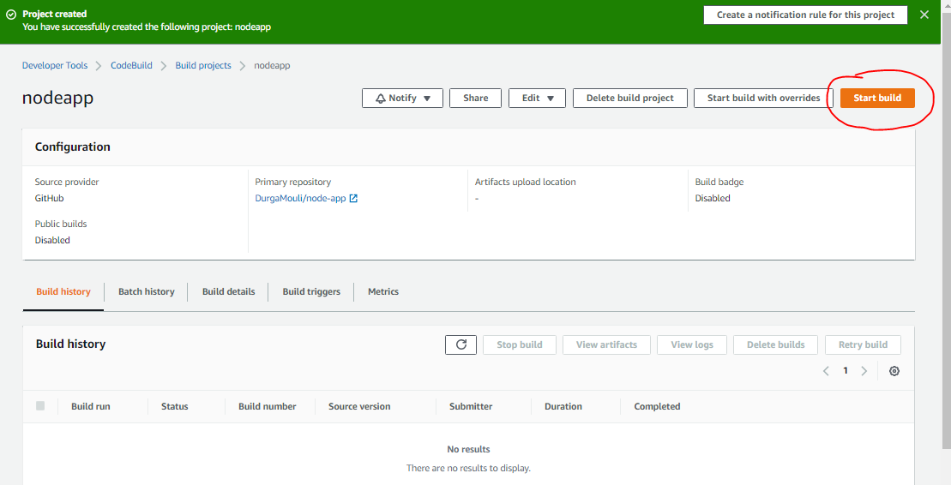

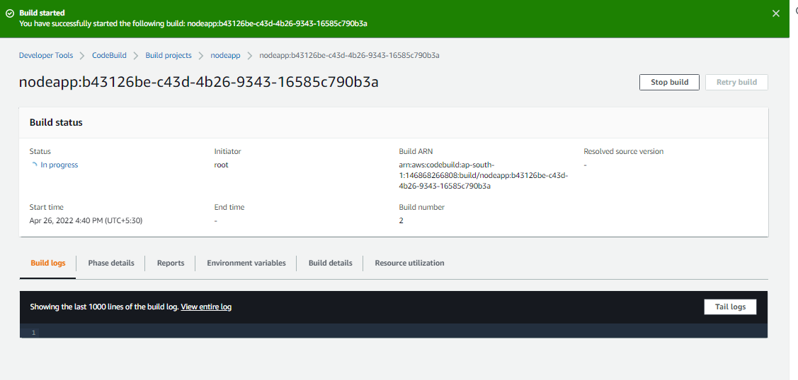

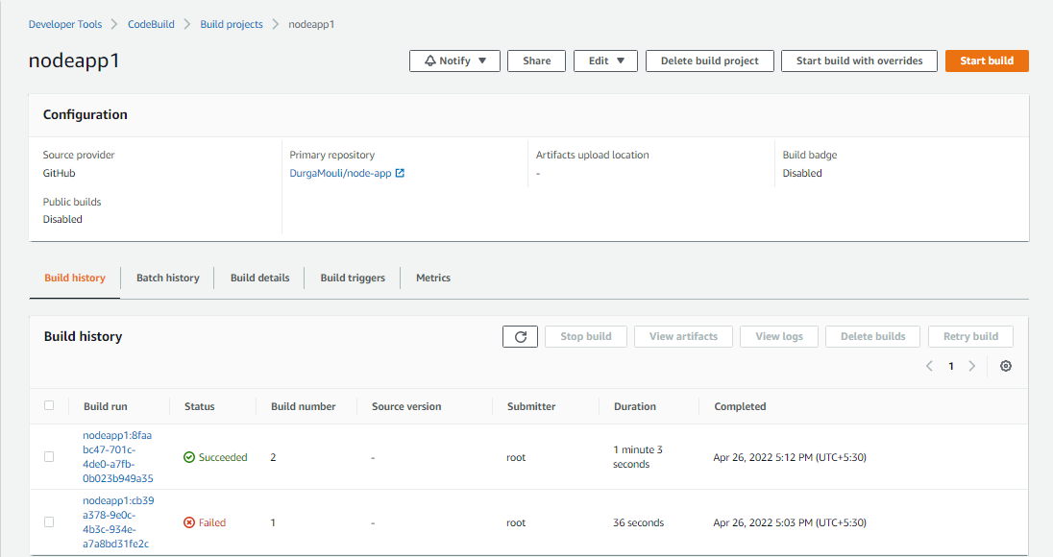

New Image has been pushed to ECR Repo:  
  
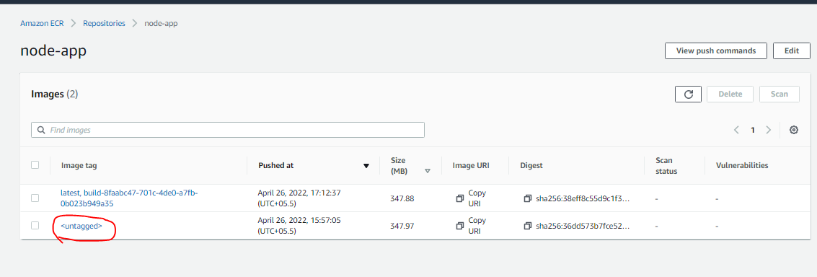

Next step is to setup code pipeline:

9) Code Pipeline:

